Figure Conceptual E-R diagram

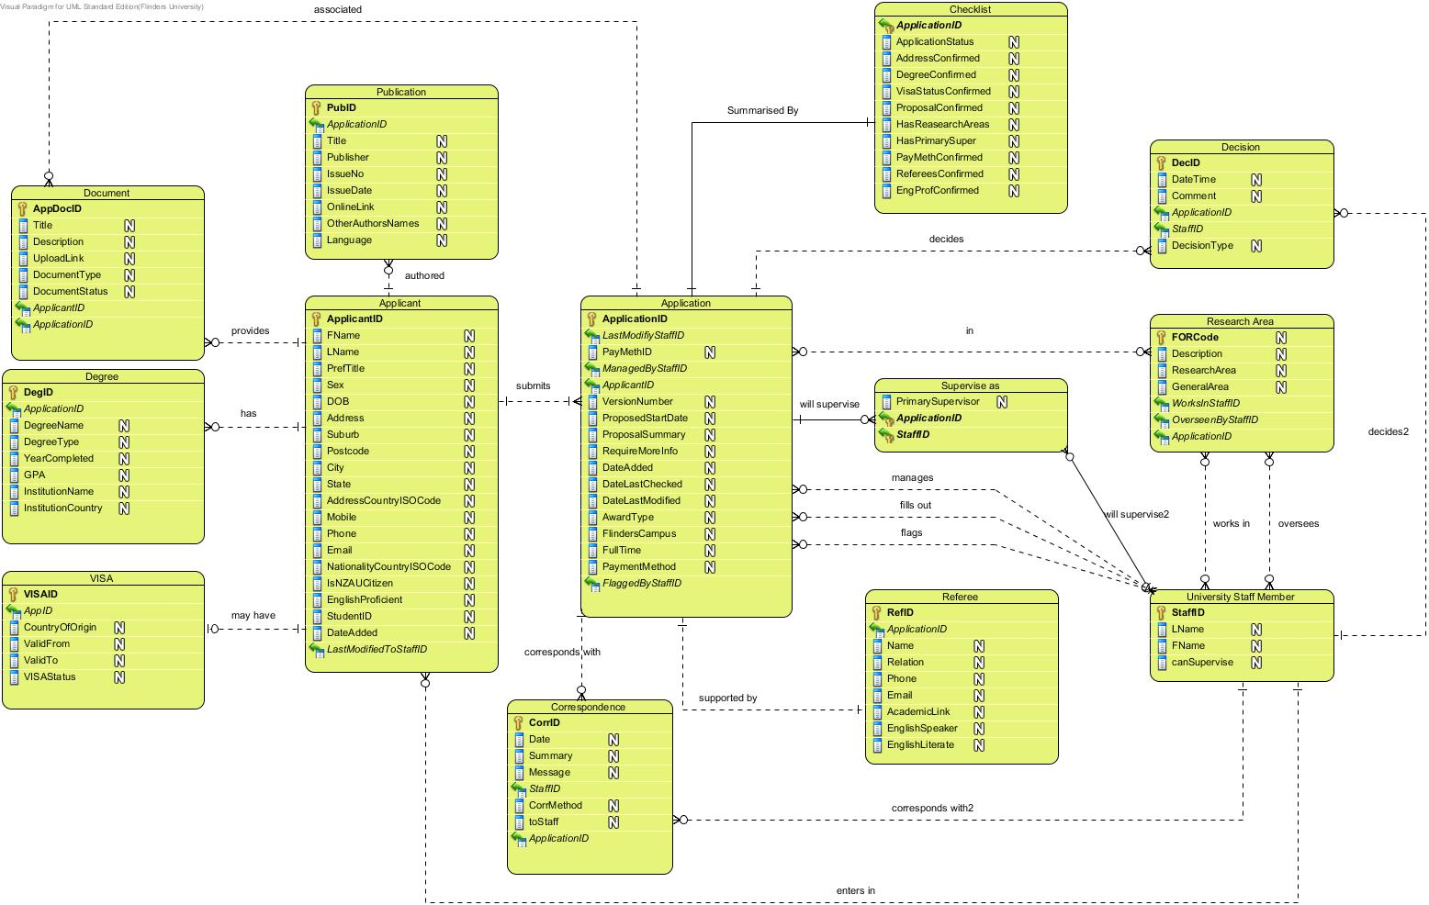

## Identified entity types

### Strong Entities

|  |  |  |  |  |
| --- | --- | --- | --- | --- |
| **Entity Name** | **Aliases** | **Description** | **Occurrences (select multiplicities)** | **Entity #** |
| Applicant | - | Holds the applicant specific details | Can be zero at the start but is expected to be many during use | 1 |
| Document | - | Links to any relevant documents along with descriptions and types. | Zero or more for each applicant, specific to the Applicant. | 2 |
| Checklist | - | Allows users to record the received and outstanding application information. | Always exactly one for each application. | 3 |
| Degree | - | Any Degrees already held by the applicant | One or more for each applicant, specific to the Applicant. | 4 |
| Application | - | Holds the application details | one or more for every Applicant | 5 |
| Publication | - | Publications that the applicant has authored | Zero or more of their publications can be added for each Applicant | 7 |
| Referee | - | A referee for the applicant | One or more for each Applicant | 8 |
| Research Area | - | The areas of a research an application or staff member is in. | a set number of predefined research areas, reusable by Staff and Applicants | 9 |
| University Staff Member | - | Supervisor or RHD Staff Member | Includes both of the above | 12 |
| Visa | - | The applicants visa details | Zero or one for each Applicant (as required) | 13 |

### Weak Entities

|  |  |  |  |  |
| --- | --- | --- | --- | --- |
| **Entity Name** | **Aliases** | **Description** | **Occurrences (select multiplicities)** | **Entity #** |
| Correspondence | Message | Correspondence between the Applicant and University Staff Member | Zero or more for every application | 14 |
| Decision | Change Log | The decision and comment made for an application by a RHD staff member | Zero or more for every application | 15 |
| SuperviseAs | Supervisor type | Supervise as a primary or secondary supervisor | One for ever supervisor | 16 |

## Identify relationship types

|  |  |  |  |  |  |
| --- | --- | --- | --- | --- | --- |
| **Entity Name 1** | **multiplicity** | **Relationship Name** | **multiplicity** | **Entity Name 2** | **Rel#** |
| Applicant | 1 | provides | 0..* | Document | 1.1 |
| 1 | Submits | 1..* | Application | 1.2 |
| 1 | holds | 1..* | Degree | 1.3 |
| 1 | has authored | 0..* | Publication | 1.4 |
| 1 | May Require | 0..1 | Visa | 1.5 |
| Application | 0..* | In | 1..* | ResearchArea | 2.1 |
| 0..* | Prefers | 1..3 | Supervise as | 2.2 |
| 1 | Summarized By | 1 | Checklist | 2.3 |
| 1 | Supported By | 0..5 | Referee | 2.4 |
| Document | 0..* | associated | 0..1 | Application | 5.1 |
| 0..* | provides | 1..1 | Applicant | 5.2 |
| RHDStaffMember | 1 | Decides | 0..* | Application | 10.1 |
| 0..* | Oversees | 0..* | ResearchArea | 10.2 |
| 1 | Manages | 0..* | Application | 10.3 |
| Supervise as | 0..* | Flags | 0..* | Application | 11.1 |
| 0..* | Will supervise | 0..* | Application | 11.2 |
| 0..* | Works in | 1..* | ResearchArea | 11.3 |
| UniversityStaffMember | 0..* | Corresponds with | 0..* | Applicant | 12.1 |
| 1 | enters in | 0..* | Applicant | 12.2 |
| 1 | Fills out | 0..* | Application | 12.3 |

## Identify and associate attributes with entity or relationship types

| Attributes by Entity | | | | | | |
| --- | --- | --- | --- | --- | --- | --- |
| **Entity Name** | **Attribute Name** | **Description** | **Data type and Length\*** | **Allow nulls** | **Multi -valued** | **attri#** |
| Applicant | fName | First name | VARCHAR(50) | N | N | 1.1 |
| lName | Last name | VARCHAR(50) | Y | N | 1.2 |
| prefTitle | Title Mr, Mrs, Miss, Dr. * | CHAR(10) | Y | N | 1.3 |
| sex | The sex of the applicant | TINYINT(1) | N | N | 1.4 |
| DOB | Date of birth | DATETIME | Y | N | 1.5 |
| address | Residence number and street of residence | VARCHAR(254) | Y | Y | 1.6 |
| suburb | The suburb of residence | VARCHAR(100) | Y | N | 1.7 |
| postcode | The postcode of residence | MEDIUMINT | Y | N | 1.8 |
| city | The city or town of residence | VARCHAR(50) | Y | N | 1.9 |
| state | The State of residence | VARCHAR(50) | Y | N | 1.10 |
| country | The country of residence | CHAR(2)** | Y | N | 1.11 |
| mobile | Mobile phone number | VARCHAR (50) | Y | N | 1.12 |
| phone | Landline phone number | VARCHAR (50) | Y | N | 1.14 |
| email | The email address of the applicant | VARCHAR(100) | N | N | 1.15 |
| nationality | The nationality of the applicant | CHAR(2)** | Y | N | 1.16 |
| isNZAUCitizen | Is a new Zealand or Australian citizen – a check to see if visa information is required *** | TINYINT(1) | Y | N | 1.17 |
| englishProficient | English ability | TINYINT | Y | N | 1.18 |
| studentID | The flinders university student id if they are or have been enrolled at flinders university | UNSIGNED MEDIUMINT | Y | N | 1.19 |
| dateAdded | The date the applicant was added to the system | DATETIME | N | N | 1.20 |
| Application | proposedStartDate | The date the applicant prefers to start the RHD (Entered as 1/1/## for S1 and 1/7/## for S2) | DATETIME | Y | N | 2.1 |
| proposalSummary | What the proposal is about | VARCHAR(2000) | Y | N | 2.2 |
| dateAdded | The date the application was submitted/saved | DATETIME | N | N | 2.3 |
| dateLastChecked | The date the application was last checked | DATETIME | N | N | 2.4 |
| dateLastModified | the date the application was last modified | DATETIME | N | N | 2.5 |
| paymentMethod | The Type of payment method | VARCHAR(50) | Y | N | 2.6 |
| awardType | An award name | VARCHAR(50) | N | N | 2.7 |
| FlindersCampus | If the study will be on site | Boolean | Y | N | 2.8 |
| FullTime | If ti will be full-time study | Boolean | Y | N | 2.9 |
| Checklist | applicationStatus | The status of the application | VARCHAR(20) | N | N | 3.1 |
| addressConfirmed | All contact details appear valid | TINYINT(1) | N | N | 3.2 |
| degreeConfirmed | The degree is a recognised degree of the institution | TINYINT(1) | N | N | 3.3 |
| visaConfirmed | The visa status is backed by an official document | TINYINT(1) | N | N | 3.4 |
| proposalConfirmed | The proposal is contains appropriate detail | TINYINT(1) | N | N | 3.5 |
| engProfConfirmed | The applicant has some level of English literacy | TINYINT(1) | N | N | 3.6 |
| hasResearchAreas | Has nominated research areas relevant to the proposal | TINYINT(1) | N | N | 3.7 |
| hasPrimarySuper | Has the required number of supervisors | TINYINT(1) | N | N | 3.8 |
| payMethConfirmed | The payment method is backed by an official document | TINYINT(1) | N | N | 3.9 |
| refereesConfirmed | The referees details appear to be correct | TINYINT(1) | N | N | 3.10 |
| Degree | name | The title of the degree | VARCHAR(100) | N | N | 4.1 |
| type | The type of the degree -  Could add specific types | VARCHAR(100) | N | N | 4.2 |
| yearCompleted | The year the degree was completed or will be completed | DATETIME | Y | N | 4.3 |
| GPA | The GPA of the degree | VARCHAR(5) | Y | N | 4.4 |
| institutionName | The name of the institution | VARCHAR(100) | Y | N | 4.5 |
| institutionCountry | The country the institution is located in | CHAR(2)** | Y | N | 4.6 |
| Document^ | title | The title of the document | VARCHAR(254) | N | N | 5.1 |
| description | A specific summary related to the document i.e. valid till 2015 etc. | VARCHAR(2000) | Y | N | 5.2 |
| uploadLink | An link to a version uploaded and stored on the university servers | VARCHAR(254) | N | N | 5.3 |
| docType | The type of document | VARCHAR(50) | N | N | 5.4 |
| docStatus | Official and translation status of a document associated to an Applicant | VARCHAR(50) | N | N | 5.5 |
| Publication | title | The title of the publication | VARCHAR(254) | N | N | 7.1 |
| abstract | A abstract/description of the publication | VARCHAR(2000) | Y | N | 7.2 |
| publication | The journal/magazine publisher | VARCHAR(254 | N | Y | 7.3 |
| issueNo | The issue/edition number of the publication | MEDIUMINT | Y | N | 7.4 |
| issueDate | The date the publication was issued | DATETIME | N | N | 7.5 |
| onlineLink | An online link to the publication | VARCHAR(254) | Y | N | 7.6 |
| otherAuthorsNames | Other authors of the publication | VARCHAR(254) | Y | Y | 7.7 |
| language | language of the publication | VARCHAR(50) | Y | N | 7.8 |
| Referee | name | The full name of the referee | VARCHAR(100) | N | N | 8.1 |
| relation | The referees relation to the applicant | VARCHAR(100) | N | N | 8.2 |
| phone | The referees phone number | VARCHAR(50) | Y | N | 8.3 |
| email | The referees email address | VARCHAR(100) | N | N | 8.4 |
| profession | The referees profession | VARCHAR(254) | N | N | 8.5 |
| academicLink | The referees professional page (linked in or university) | VARCHAR(254) | Y | N | 8.6 |
| englishSpeaker | If the Referee can speak English | TINYINT(1) | Y | N | 8.7 |
| englishLiterate | If the Referee can read and write in English | TINYINT(1) | Y | N | 8.8 |
| ResearchArea | FORCode | The Australian Field Of Research (FOR) code | SMALLINT | N | N | 9.1 |
| Description | A small text description of the FOR i.e. 2201 | VARCHAR(2000) | N | N | 9.2 |
| researchArea | The FOR title; i.e. Applied Ethics | VARCHAR(50) | N | N | 9.3 |
| generalArea | The general area of the FOR | VARCHAR(50) | N | N | 9.4 |
| Supervise as | - | - | - | - | - | 11 |
| UniversityStaffMember | staffID | The flinders uni staff id number | MEDIUMINT | N | N | 12.1 |
| fName | The first name of the staff member | VARCHAR(50) | N | N | 12.2 |
| lName | The last name of the staff member | VARCHAR(50) | N | N | 12.3 |
| canSupervise | If the staff member can supervise RHD candidates | Boolean | N | N | 12.4 |
| Visa | validFrom | When the visa is valid from | DATETIME | Y | N | 13.1 |
| validTo | When the visa is valid to | DATETIME | Y | N | 13.2 |
| VisaStatus | Approved unapproved, submitted, waiting etc. | VARCHAR(50) | N | N | 13.3 |

|  |  |  |  |  |  |  |
| --- | --- | --- | --- | --- | --- | --- |
| Attributes types by Association Entity | | | | | | |
| **Entity Name** | **Attribute Name** | **Description** | **Data type and Length\*** | **Allow nulls** | **Multi -valued** | **attri#** |
| Correspondence | date | The date the correspondence was made/received | DATETIME | N | N | 14.1 |
| summary | A small summary of the Correspondence | VARCHAR(1000) | Y | N | 14.2 |
| message | The actual message contained in the correspondence | VARCHAR(1000) | N | N | 14.3 |
| corrMeth | The method of correspondence. | VARCHAR(50) | N | N | 14.4 |
|  | toStaff | The direction of the correpondance | TINYINT(1) | N | N | 14.5 |
| Decision | date | The date the decision was made on | DATETIME | N | N | 15.1 |
| comment | Extra information about the decision | VARCHAR(1000) | Y | N | 15.2 |
| decType | The type of decision | VARCHAR(50) | N | N | 15.3 |
| SuperviseAs^^ | primarySupervisor | True will supervise as primary supervisor else as a secondary supervisor | TINYINT(1) | N | N | 16.1 |

Related information

* types not specifically set

** uses the ISO 3166-1 alpha-2 code

*** as per the Australian High Commission New Zealand - <http://www.newzealand.embassy.gov.au/wltn/study.html>

^ a degree, publication, visa or other document may include

^^ primary supervisors are decided on a first come first serve basis

Field lengths are based on the approximation that 500 chars is approximately 100 words

2000~400 words

## Determined Domain attribute domains

|  |  |  |  |  |
| --- | --- | --- | --- | --- |
| **Entity Name** | **Attribute Name** | **Domain (includes validation information)** | **Default value** | **attri#** |
| Applicant | prefTitle | - | - | 1.3 |
| Sex | Male/Female | - | 1.4 |
| DOB | >16 years old | - | 1.5 |
| country | ISO 3166-1 alpha-2 code | - | 1.11 |
| email | Is a valid Email address | - | 1.15 |
| Nationality | ISO 3166-1 alpha-2 code | - | 1.16 |
| isNZAUCitizen | y/n | - | 1.17 |
| englishProficient | (~0-120) TOEFL Score | - | 1.18 |
| studentID | >1,000,000 and <2,500,000 | - | 1.19 |
| dateAdded | Is a date | CURDATE() | 1.30 |
| Application | proposedStartDate | > CURDATE() and CURDATE()+5years< | - | 2.1 |
| dateAdded | - | CURDATE() | 2.3 |
| dateChecked | - | CURDATE() | 2.4 |
| dateLastModified | Always CURDATE() on Application or its relationships change | CURDATE() | 2.5 |
| paymentMethod | * student loan * savings * government assistance (AU) * government assistance (Foreign government) * scholarship | - | 2.6 |
| awardType | * Master of Arts * Master of Biotechnology * Master of Business * Master of Clinical Education * Master of Clinical Rehabilitation * Master of Engineering * Master of Laws * Master of Science * Master of Surgery * Master of Theology * Doctor of Philosophy (PhD) in all disciplines * Doctor of Philosophy (Clinical Psychology) – includes some coursework. * Doctor of Education * Doctor of Public Health   Cotutelle Doctorate – (Flinders University and an international higher education institution) | - | 2.7 |
| FlindersCampus | * T/F | - | 2.8 |
| FullTime | * T/F | - | 2.9 |
| Checklist | applicationStatus | * Rejected – application is rejected * not eligible – applicant is found to be unable to apply * Unfinished – the application still requires information/unfinished * Proposed – the application is finished and proposed * Flagged – staff have flagged as interested * Partially assigned – some staff have agreed to supervise * Assigned – staff have agreed to supervise * Formal pending – all details are in order, formal process starts * Approved – formal application is approved | Unfinished | 3.1 |
| addressConfirmed | Y/N | N | 3.2 |
| degreeConfirmed | Y/N | N | 3.3 |
| visaConfirmed | Y/N | N | 3.4 |
| proposalConfirmed | Y/N | N | 3.5 |
| engProfConfirmed | Y/N | N | 3.6 |
| hasResearchAreas | Y/N | N | 3.7 |
| hasPrimarySuper | Y/N | N | 3.8 |
| payMethConfirmed | Y/N | N | 3.9 |
| refereesConfirmed | Y/N | N | 3.10 |
| Degree | type | * Certificate * Associate Degrees * Diploma * Postgraduate diploma * Bachelor Degree * Bachelor(honours) * Graduate Diploma * Graduate Certificate * Masters * Graduate Entry Masters * Professional Masters * PHD | - | 4.2 |
| yearCompleted | >CURDATE-2YEARS | - | 4.3 |
| GPA | >0 and <10 | - | 4.4 |
| institutionCountry | ISO 3166-1 alpha-2 code | - | 4.6 |
| Document | uploadLink | Is a URL | - | 5.0 |
|  | docType | * Paper * Academic transcript * Proposal * Proof of financial ability * Visa application acceptation paper * other | - | 5.4 |
|  | docStatus | * Official * Unofficial * Official translation * Unofficial translation * N/A | - | 5.5 |
| Publication | issueDate | >CURDATE-50YEARS and <CURDATE+1 | - | 7.5 |
| onlineLink | isURL | - | 7.6 |
| Referee | phone | isPhone | - | 8.3 |
| email | isEmail | - | 8.4 |
| academicLink | Is html page | - | 8.6 |
| englishSpeaker | Y/N | - | 8.7 |
| englishLiterate | Y/N | - | 8.8 |
| ResearchArea | FORCode | FORCode | - | 9.1 |
| Description | - | - | 9.2 |
| researchArea | FORCode tilte | - | 9.3 |
| generalArea | * DIVISION 01 MATHEMATICAL SCIENCES * DIVISION 04 EARTH SCIENCES * DIVISION 05 ENVIRONMENTAL SCIENCES * DIVISION 08 INFORMATION AND COMPUTING SCIENCES * DIVISION 09 ENGINEERING * DIVISION 10 TECHNOLOGY | - | 9.4 |
| VISA | countryOfOrigin | ISO 3166-1 alpha-2 codes | - | 13.1 |
| VISAStatus | * student visa * unknown | unknown | 13.2 |

Attribute Entity Domains

|  |  |  |  |  |
| --- | --- | --- | --- | --- |
| Correspondence | CorrMethod | * Phone * Email * Skype * Mail | - | 14.1 |
| toStaff | Y/N | - | 14.5 |
| Decision | Type | * Status change – Application status change (status to from added automatically by * Info request – a request has been made for Information * requested * Application handed over to | - | 15.1 |

- Not null no default

* Possible but will not be implemented

## Determined candidate, primary, and alternate key attributes

As we want to support use with only minimal partial data. Hence, almost all attributes accept NULL. As nullable fields cannot participate in

|  |  |  |  |
| --- | --- | --- | --- |
| **Entity Name** | **Primary Key** | **Alternative Key** | **Entity#** |
| Applicant | applicantID | emailAddress lName fName, Phone lName fName  streetAddress lName fName, | 1 |
| Document | AppDocD | - | 2 |
| Application | applicationID | - | 3 |
| Checklist | applicantID | - | 4 |
| Degree | degreeID | - | 5 |
| GeneralStaffMember | staffID | - | 6 |
| Publication | pubID | - | 7 |
| Referee | refID | - | 8 |
| ResearchArea | FORCode | - | 9 |
| RHDStaffMember | staffID | - | 10 |
| Supervise as | staffID | fName + Research Areas | 11 |
| UniversityStaffMember | staffID | - | 12 |
| Visa | visaID | - | 13 |
| Correspondence | corrID | Date & Staff ID & applicantID | 14 |
| Decision | decID | - | 15 |
| SuperViseAs | staffID&applicaitonID | - | 16 |

Most relations do not have any alterative primary keys i.e. a person can have the same checklist state, hold the same degrees, specify the same supervisors and while unlikely published the same publications, have the same referees and have similar visa details.

It should be noted that Supervisor, General Staff Member and RHD staff Member all have the same primary key as they will all be merged into University Staff Member with a discriminated added to state the type as none of these specialised classes have any specific data types.

## Use enhanced modelling concepts

We investigated the use of generalisation relations between different staff member types. It was found that this approach did not yield much simplification, as there are few attributes either shared or distinct between the staff types.

We investigated the use of generalisation relation from Application Document to Publication, Degree, Visa, Application or Payment Method. This approach was rejected as we found there were too many distinct attributes among the specialised entities.

## Check model for errors and redundancy

1. Re-examine one-to-one (1:1) relationships;

All entity objects identified are unique or form part of a generalisation specialisation set

The checklist 1-1 relationship is preserved to make it separate to the application it is related to

1. Remove redundant relationships;

Applicant provides ApplicationDocument left in to account for other documents

No redundant relationships were found as each relationship in the diagram reflects a unique database transaction

1. Consider time dimension.

Many relationships multiplicities are “zero to”s to signify that details for a degree, VISA etcs are not available or cannot be entered at the current time.

These are then checked through not nulls and noted as being valid for the application (not the DB) in the checklist.

1. Check for fan traps and chasm traps.

Fan Trap

Where a model represents a relationship between entity types, but pathway between certain entity occurrences is ambiguous.

Chasm Trap

Where a model suggests the existence of a relationship between entity types, but pathway does not exist between certain entity occurrences.

## Validate conceptual model against user transactions

Identify transaction pathways and check that they will work.

The following user pathways were tested:

Table 1 User transactions for all staff, including professional staff

|  |  |
| --- | --- |
|  | Look up applicant + publications + degrees + visa Status + Associated documents by applicant name |
|  | Look up applicant’s applications by applicant name |
|  | Look up applicant’s applications by applicant email |
|  | Look up incomplete applications |
|  | Look up all correspondences relevant to the application |
|  | Insert Applicant |
|  | Who edited the Applicant/Application last |
|  | Create new applicant and associated application records |
|  | Look up an existing application and attach a new standard type document to an application |
|  | Look up an existing application and attached a new exceptional type document to an application |
|  | Look up an existing application and list outstanding information (checklist). |
|  | Elevate the certainty status flag of a piece of information relating to an existing application |
|  | Retrieve all on-going applications for which the user has made the most recent correspondence |
|  | Record making a decision about an application |
|  | Update the status of an application |

Table 2 User transactions for academic staff

|  |  |
| --- | --- |
|  | Look up, add to, and delete from own current research areas |
|  | Search for all applications in certain research areas that have been added since a certain time |
|  | Flag interest in an application |

Table 3 User transactions for RHD co-ordinations staff

|  |  |
| --- | --- |
|  | Who edited the Applicant/Application last |
|  | Retrieve all ongoing applications |
|  | List all ongoing applications that do not have a primary supervisor allocated. |

Note that going through transaction f) forced changes to the conceptual design; these are noted in the Change Log section 2.13 item a).

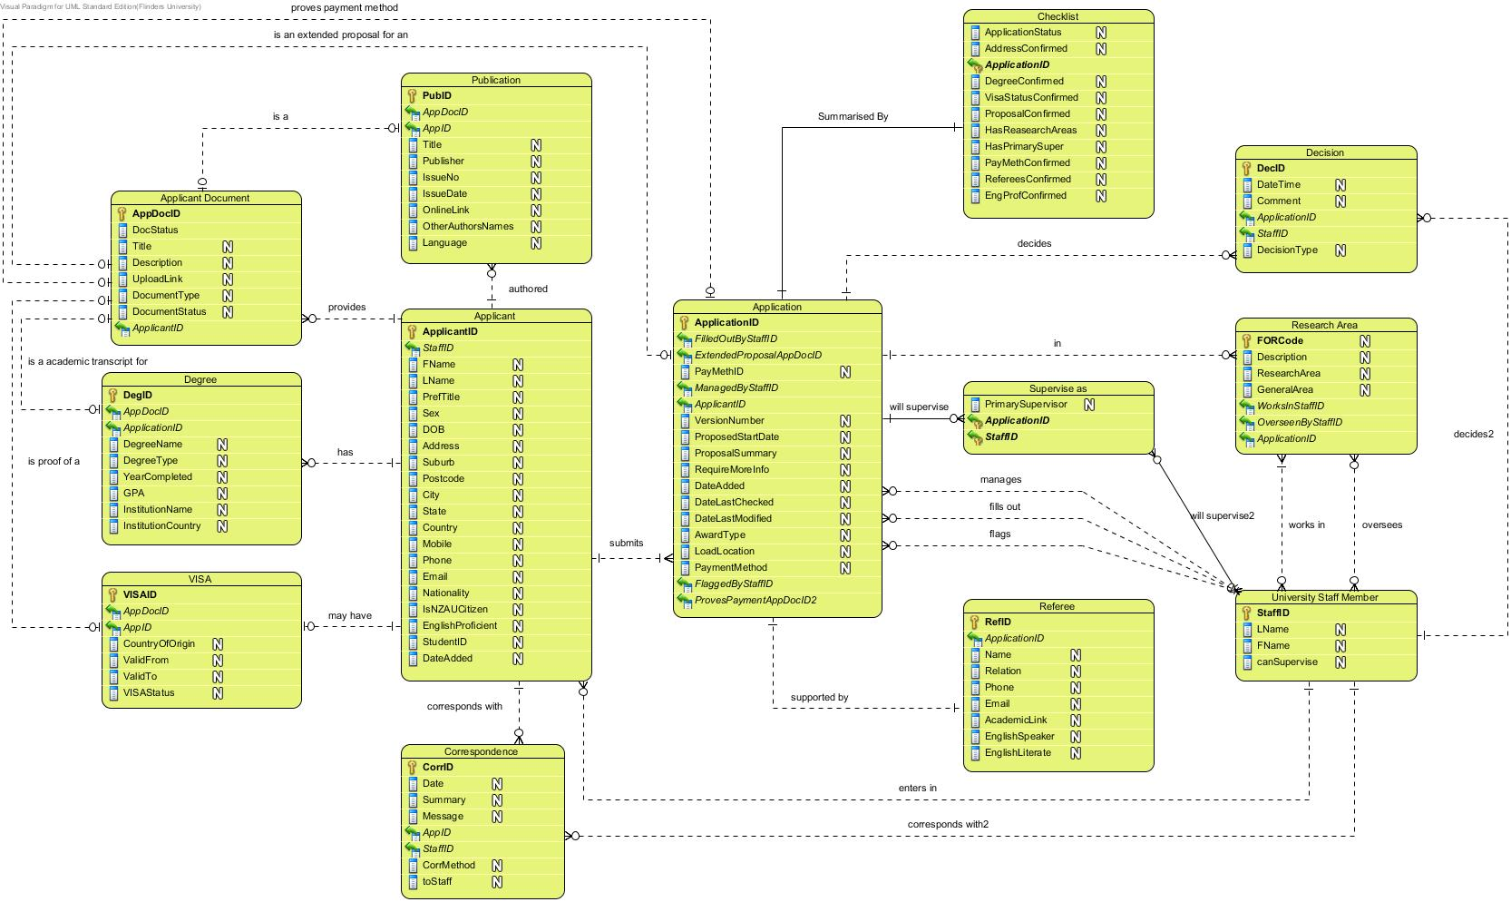

**a**

**a**

**a, i, k, l**

**b, d, h**

**a**

**e, m**

**e, g**

**e, m**

**n**

**p**

**q**

**r**

**s**

**f**

**k,o,t**

**u**

Figure

## Develop draft test plan

We will generate a test data set to represent a baseline state of a running system. This includes a way to automatically load this baseline data into database system. This data set will need to be realistic, to ensure we are testing the system in a similar way in which it will be used. It will also have to be comprehensive to ensure that it tests integrity constraints.

We will also generate scripts that perform additional create, retrieve, update and delete operations that simulate a set of realistic user transactions, as listed in section 2.10. These scripts will include details of the expected result of each operation, to enable logging success/failure and time taken of each test.

As changes are made to the implementation of the system, we will compare the test logs before and after changes to ensure the system performance is improving overall.

As problems are discovered in the system implementation, ensure that the test suites are updated to include these newly discovered problems, to prevent reintroducing these errors.

We will evaluate for use the unit testing framework STK/Unit (Picchiarelli and Razzoli 2013). If this product works as claimed, using it will simplify constructing and executing tests, and also evaluating the system performance against those tests, and tracking that performance over time.

The functions to be tested include that all the user transactions are supported:

|  |  |
| --- | --- |
| # | pathway |
|  | Look up applicant + publications + degrees + visa Status + Associated documents by applicant name |
| Tested by five separate queries, where |
|  | Look up applicant’s applications by applicant name |
|  | Look up applicant’s applications by applicant email |
|  | Look up incomplete applications |
|  | Look up all correspondences relevant to the application |
|  | Insert Applicant |
|  | Who edited the Applicant/Application last |
|  | Create new applicant and associated application records |
|  | Look up an existing application and attach a new standard type document to an application |
|  | Look up an existing application and attached a new exceptional type document to an application |
|  | Look up an existing application and list outstanding information (checklist). |
|  | Elevate the certainty status flag of a piece of information relating to an existing application |
|  | Retrieve all on-going applications for which the user has made the most recent correspondence |
|  | Record making a decision about an application |
|  | Update the status of an application |

Academic Staff

|  |  |
| --- | --- |
| # | pathway |
|  | Look up, add to, and delete from own current research areas |
|  | Search for all applications in certain research areas that have been added since a certain time |
|  | Flag interest in an application |

RHD Co-ordination Staff

|  |  |
| --- | --- |
| # | pathway |
|  | Who edited the Applicant/Application last |
|  | Retrieve all ongoing applications |
|  | List all applications waiting for supervisor agreement |

## Review conceptual data model

The conceptual model has been reviewed against the SRS, the original project description and reviewed by an end-user stakeholder (tutor). It was found that conceptual model presented here in will meet the data requirements of RHD admissions office.

The decisions made and new terminology in this document have been appended to the requirements specification.

## Change Log

1. Document type, Document Status, Application Status, Correspondence Method, Payment Method and Decision types all moved to separate entities of know finite tuples
2. Application’s Fulltime and internal attributes combined and moved to Study Load and Location
3. dateLastModifed and dateLastChecked added to application, these will also be updated in the latest application version if an applicant is updated at the same time as requiresMoreInfo is checked
4. fills out and enters in relationships added to University Staff Member
5. Supervise as added moved supervise relationship.
6. country added to Conceptual diagram but no added here
7. Removed Document type, Document Status, Application Status, Correspondence Method, Payment Method and Decision types entities, replaced with attributes. The document was then updated to reflect this change.
8. Added user transaction u) after feedback provided.
9. Updated the model and diagram to reflect later simplifications.
10. Updated enhanced modelling concepts section to reflect simplifications.

## Other considerations and Decisions to be made

|  |  |
| --- | --- |
| **Question** | **affects** |
| Does an applicant always say what research they want to do? | Submits application multiplicity |
| Is there a GPA conversion method available |  |

**Assumptions**

* Applicant will always have enough information for an Application (proposal summary, start date, award they seek and load and location)
* The application will run the minimum submission checklist (not the checklist entity which is for user use only) after each update and: update the most recent applications; if more information is required; and update the dateLastModified.